Experiment – 9
Compare Linear and Polynomial Regression using Python

Aim
To implement and compare Linear Regression and Polynomial Regression algorithms using Python and evaluate their performance on a non-linear dataset.
Algorithm:
- Import the required Python libraries.
- Generate a sample non-linear dataset.
- Split the dataset into training and testing sets.
- Train a Linear Regression model.
- Transform the input features into polynomial features.
- Train a Polynomial Regression model.
- Predict the output values using both models.
- Evaluate the models using Mean Squared Error (MSE) and R² Score.
- Plot the regression curves for comparison.
- Compare the performance of both models.

Program:

# Step 1: Import Libraries
import numpy as np
import matplotlib.pyplot as plt

from sklearn.model_selection import train_test_split
from sklearn.linear_model import LinearRegression
from sklearn.preprocessing import PolynomialFeatures
from sklearn.metrics import mean_squared_error, r2_score

# Step 2: Generate Sample Non-linear Dataset
np.random.seed(42)

X = np.linspace(-5, 5, 100).reshape(-1,1)
y = X**2 + 3*X + 5 + np.random.normal(0,2,(100,1))

# Step 3: Split Dataset
X_train, X_test, y_train, y_test = train_test_split(
X, y, test_size=0.2, random_state=42
)

# -----------------------------
# Linear Regression
# -----------------------------
linear_model = LinearRegression()
linear_model.fit(X_train, y_train)
y_pred_linear = linear_model.predict(X_test)

# -----------------------------
# Polynomial Regression
# -----------------------------
poly = PolynomialFeatures(degree=2)

X_train_poly = poly.fit_transform(X_train)
X_test_poly = poly.transform(X_test)

poly_model = LinearRegression()
poly_model.fit(X_train_poly, y_train)

y_pred_poly = poly_model.predict(X_test_poly)

# Step 4: Evaluation

print("Linear Regression")
print("-----------------")
print("MSE :", mean_squared_error(y_test, y_pred_linear))
print("R2 Score :", r2_score(y_test, y_pred_linear))

print("\nPolynomial Regression")
print("----------------------")
print("MSE :", mean_squared_error(y_test, y_pred_poly))
print("R2 Score :", r2_score(y_test, y_pred_poly))

# Step 5: Plot Comparison

plt.figure(figsize=(10,6))

plt.scatter(X, y, color='blue', label='Actual Data')

# Linear Line
plt.plot(X, linear_model.predict(X), color='red', linewidth=2,
label='Linear Regression')

# Polynomial Curve
X_grid = np.linspace(X.min(), X.max(), 200).reshape(-1,1)
plt.plot(X_grid,
poly_model.predict(poly.transform(X_grid)),
color='green',
linewidth=3,
label='Polynomial Regression')

plt.xlabel("X")
plt.ylabel("Y")
plt.title("Linear vs Polynomial Regression")
plt.legend()
plt.show()

Output:
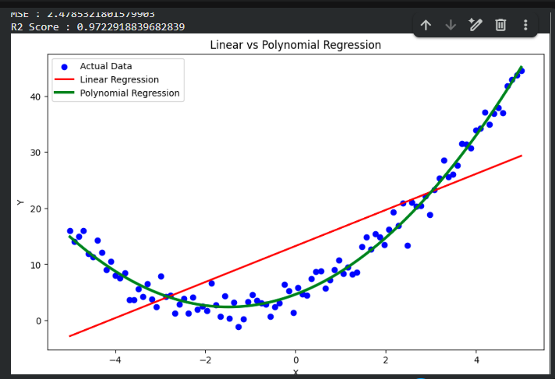

Result:
The Linear Regression and Polynomial Regression models were successfully implemented and compared. The Polynomial Regression model achieved a lower Mean Squared Error (MSE) and a higher R² Score, demonstrating better performance on the non-linear dataset. Hence, Polynomial Regression is more suitable for modeling non-linear relationships than Linear Regression.

